STEP 1: Creating an EC2 Instance

SS1: User data field showing mysql installation

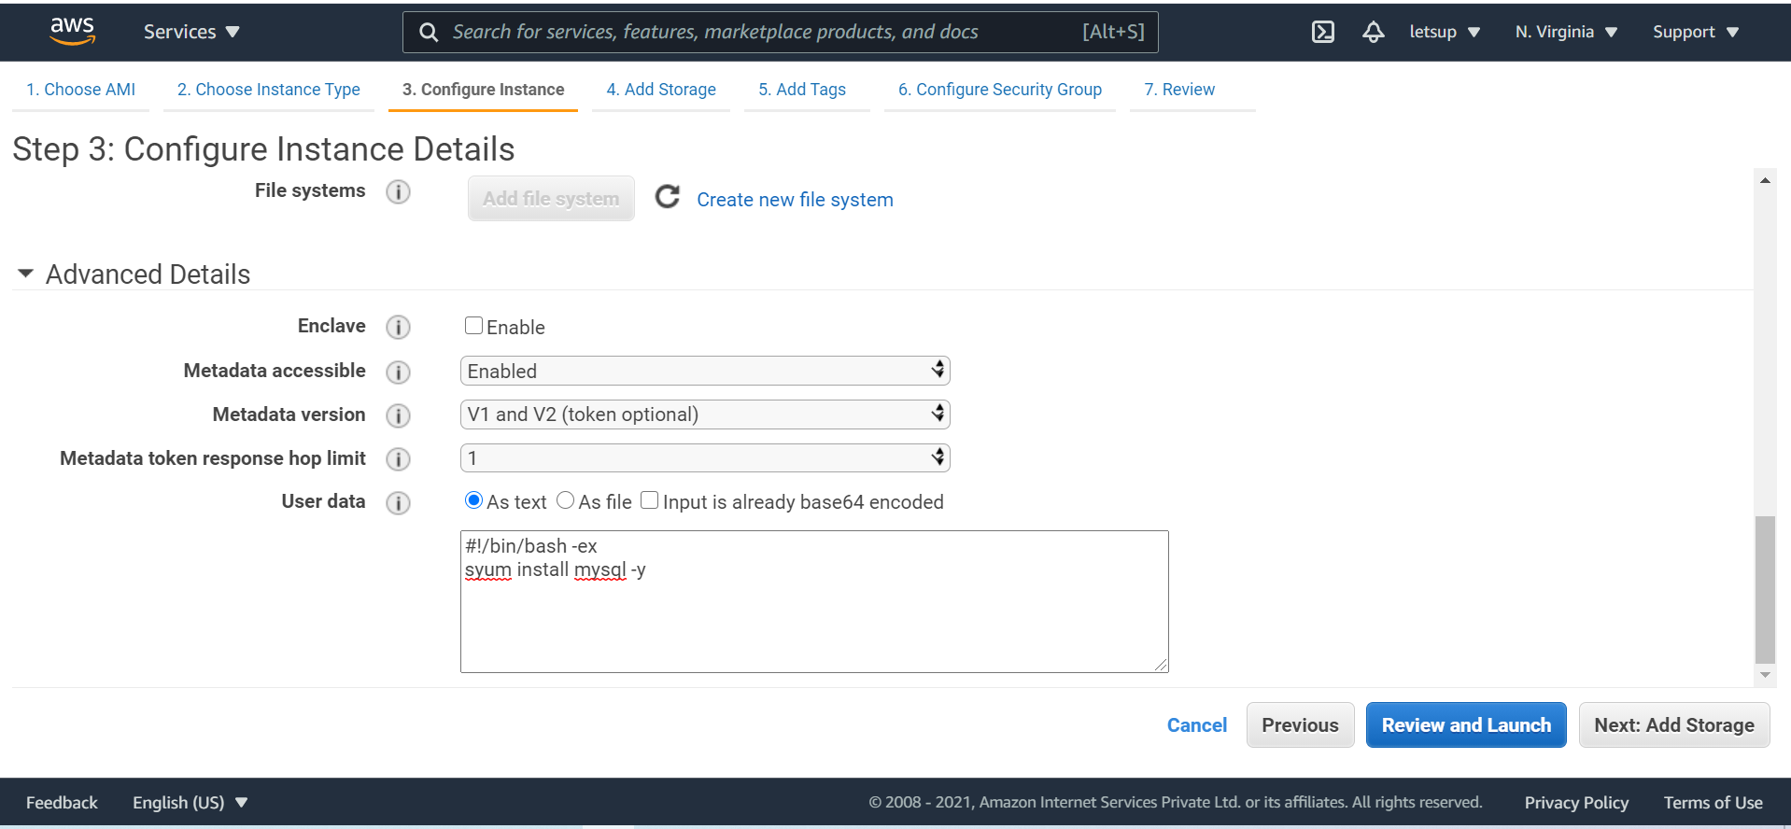

SS2: Display Security Group myserver

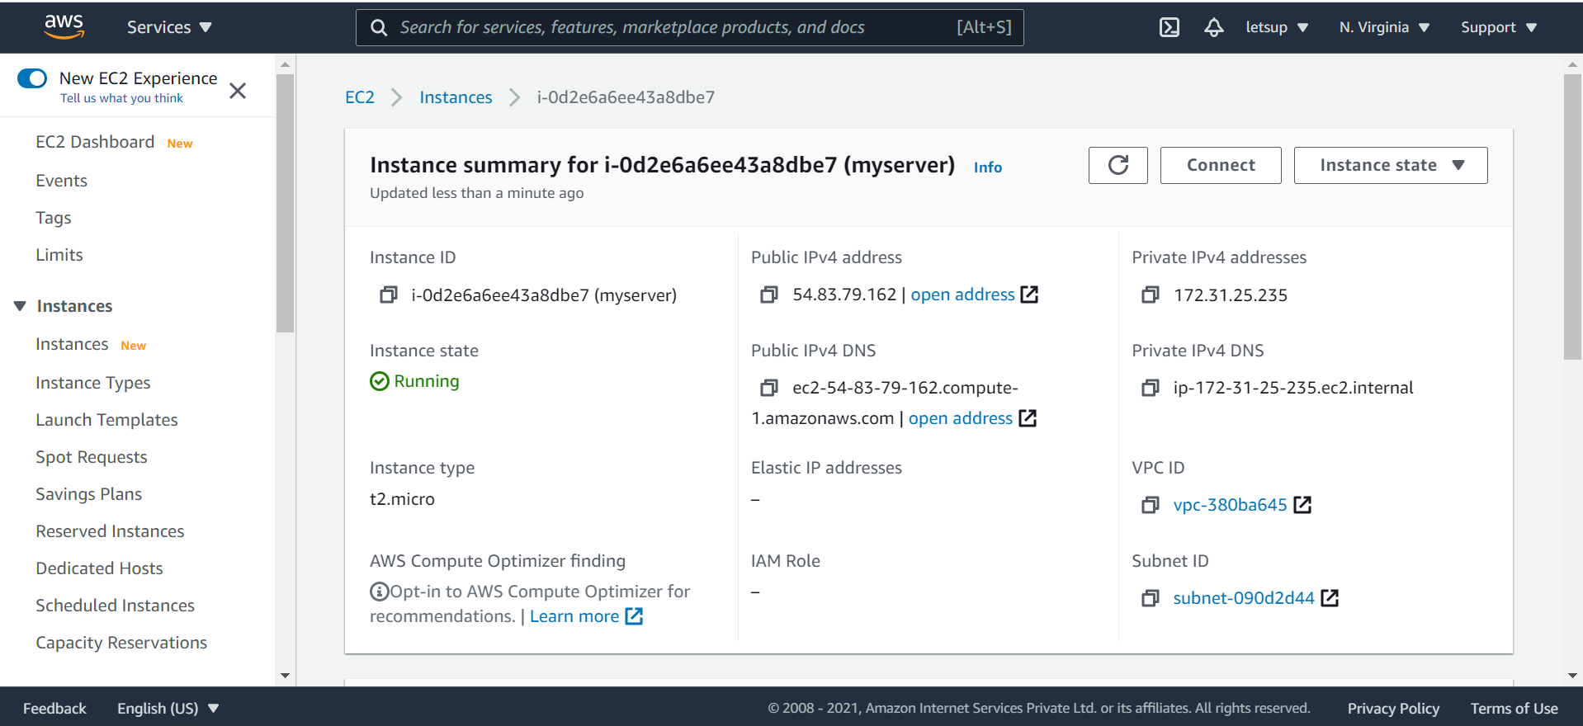

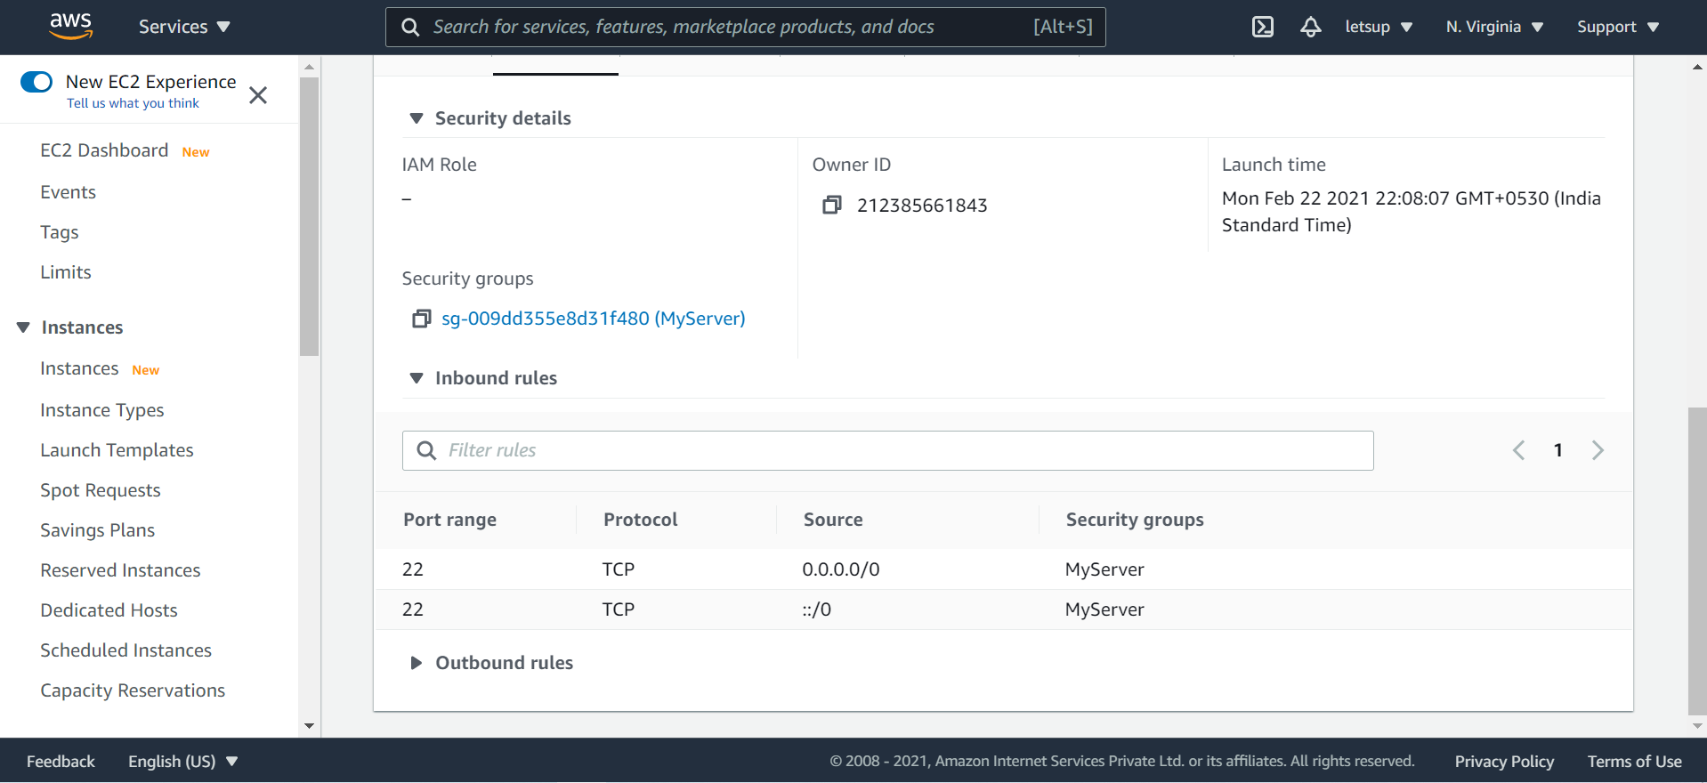

* Created Instance Details:

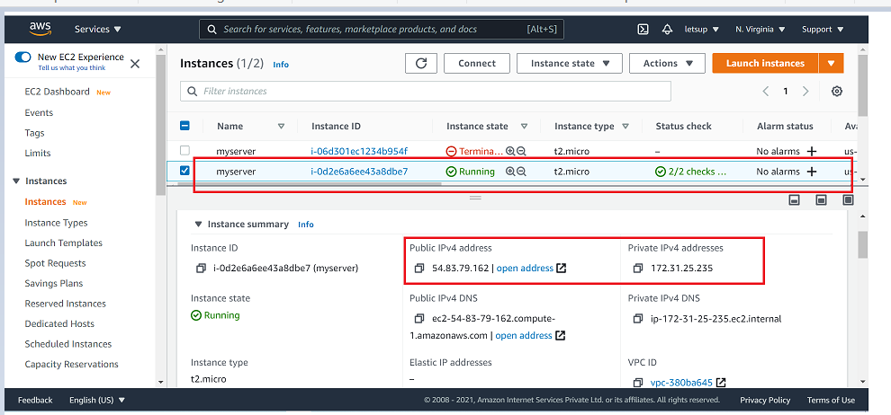

Step 2: Creating Security Group for RDS instance

* SS2: Now create a security group with the name MYEC2server-SG, and set the type as SSH and source as custom.

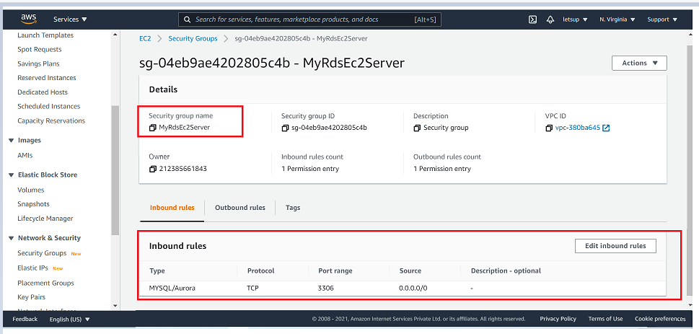

* Inbound rules: o Type: MySQL/Aurora Protocol: TCP Port range: 3306

Step 3: Create an Amazon Aurora database with Multi-AZ enabled

SS3: Display Enabling Multi AZ

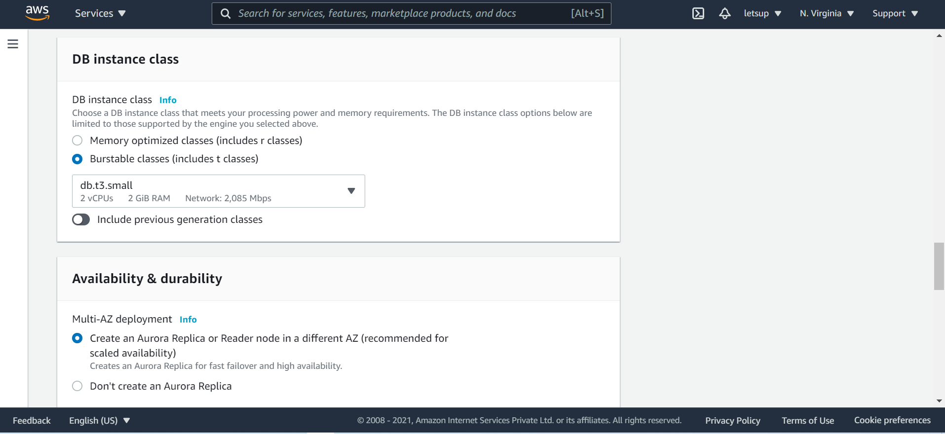

* DB instance size:
* Burstable classes - db.t3.small (1 CPU, 2GB RAM)
* Availability & durability:
* Multi-AZ Deployment
* Create an Aurora Replica or Reader node in different AZ

Step 4: Connecting to the Aurora (MySQL) database on RDS

SS6: Show databases console with reader and writer

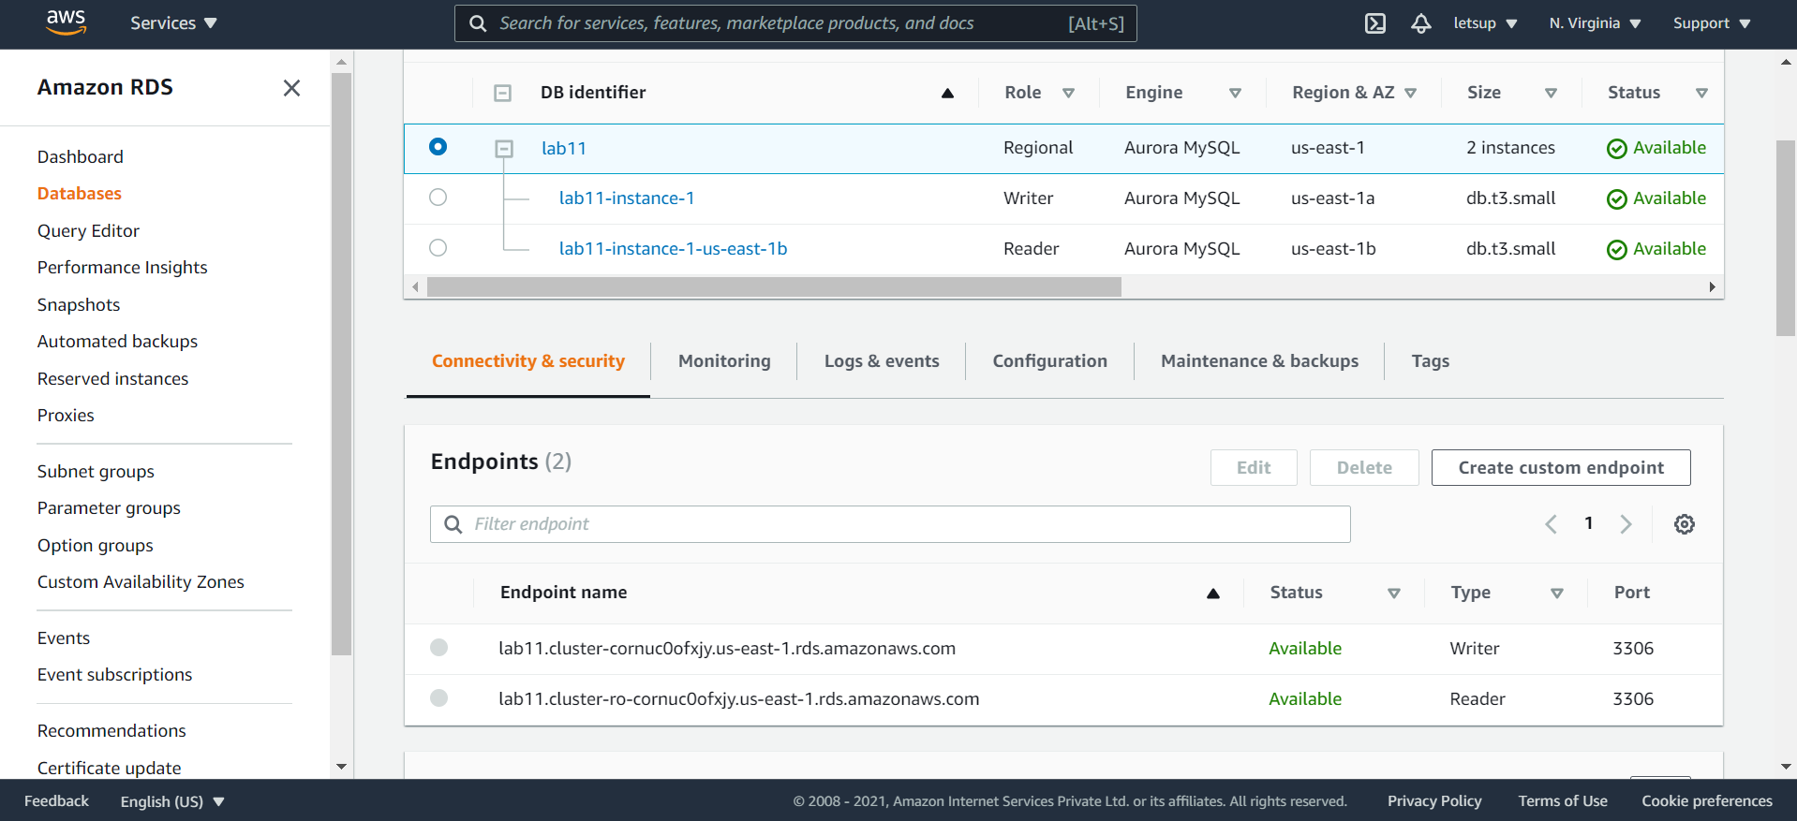

Step 5: Successfully launched the instance and connected to databases

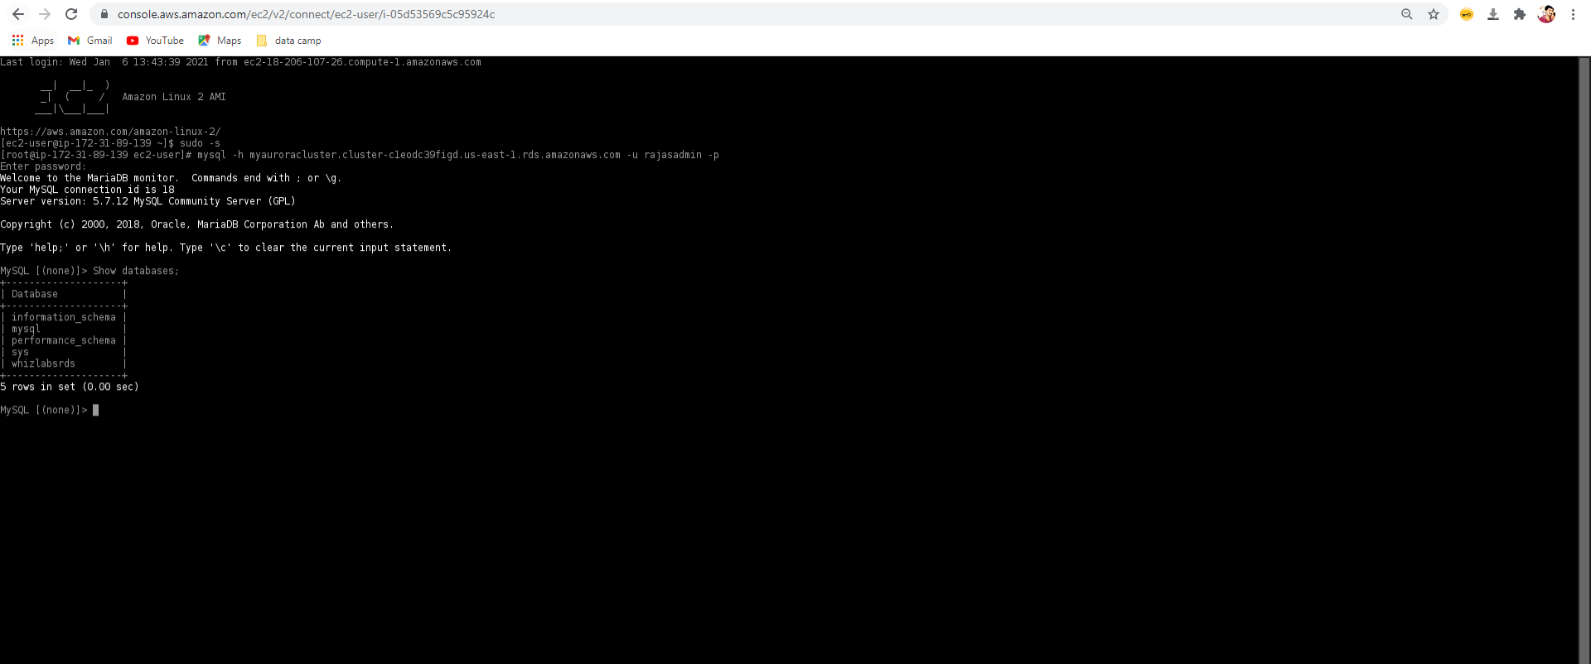

Step 6 : Successfully inserted the records into DB

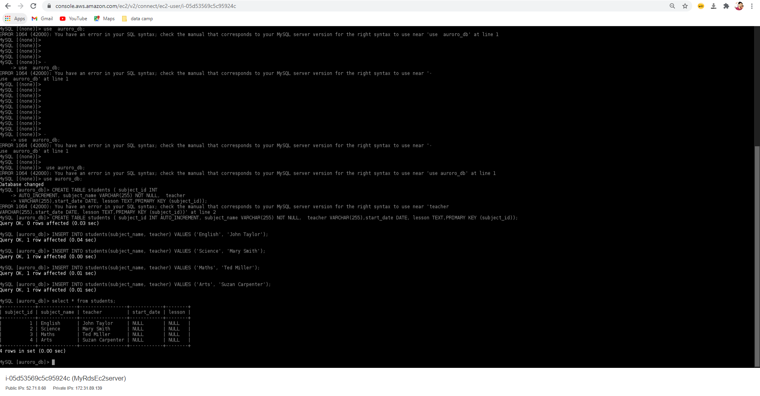

Step 7 : performed fail over

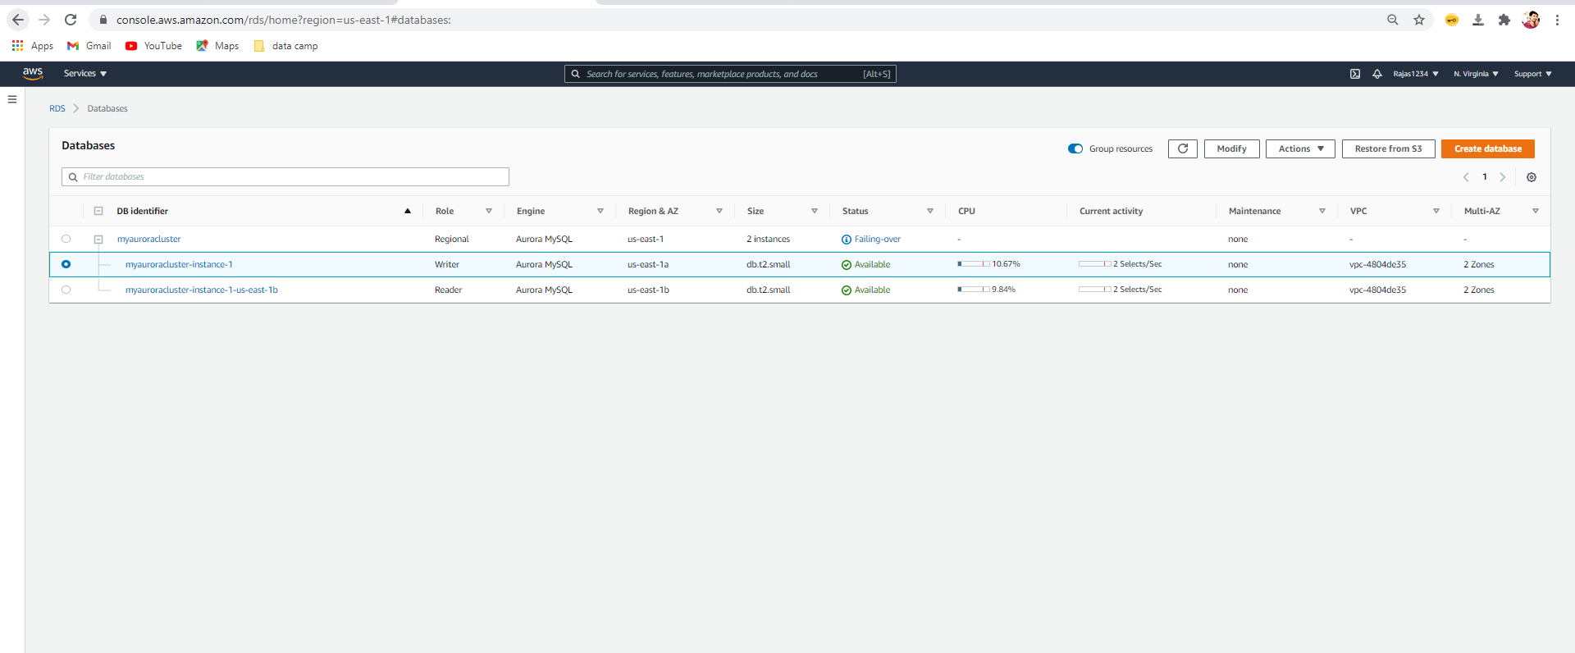

Step 7 - Master became reader and another became writer

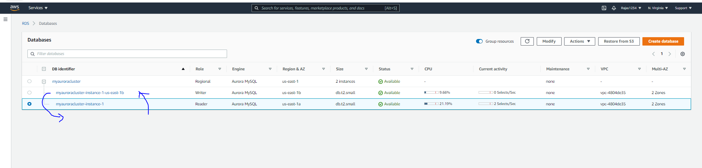

Step 8 : connecting with failover databases

Can see the database and records in my failover writer

